CS790 Team-4 Milestone 3

**Essential Software Design—UML**

* **Architectural Design**

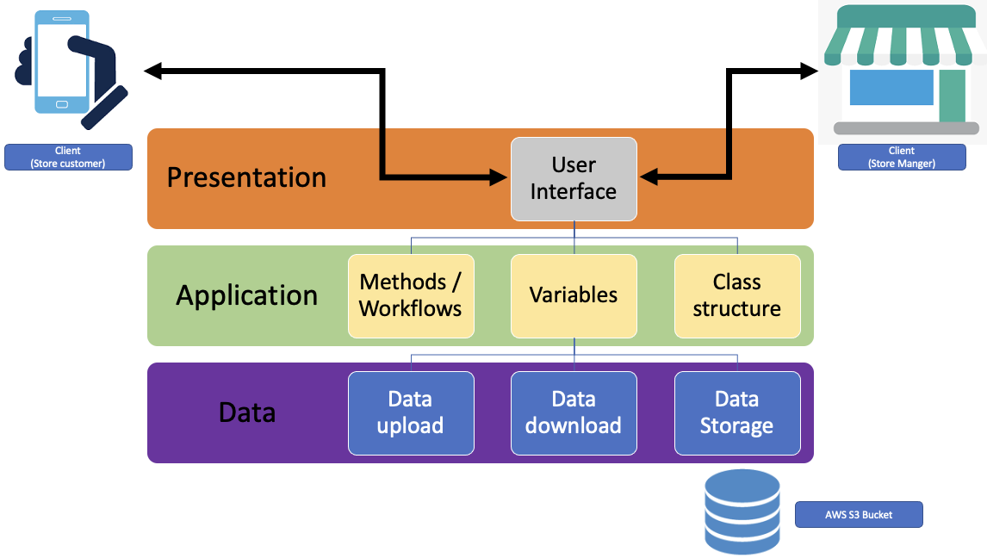

Presentation Layer: User Interface

* 2 different workflow paths but with a similar structure of the UI to optimize our efficiency.
  + Store Customer
  + Store Manager

Application Layer: Core Application Functionality

* + Workflows:
    - Store Customer
      * sign in→ select whether or not they are ordering online or shopping in store→ in the first case, if they are shopping online, creating a cart, adding items to the cart based on availability → pay for goods → schedule a pick up time → receive a digital receipt. For the second case if the shopper is going “in store”, user credentials → see current capacity and line → receive a recommendation whether they should come to the store now or suggest better times to come.
    - Store Manager
      * Credentials → see current status of store capacity and line → offer the ability to change capacity.
  + Variables (Structured below in relational database design)
  + Class Structure (Structured below in relational database design)

Data Layer: Data storage and download/upload flows

* API to interface with Data Storage to download / upload based on workflow.
* Data storage: Something like AWS S3 (For this application we will model a database system in application for presentation and will not use an outside database like the AWS S3)
* **Use-Case Scenarios**

Expand the previous documentation of the initial use-case diagram into use-case scenarios.

We have already mentioned the use case scenarios in milestone 3 .So This time I have created the use case diagram.

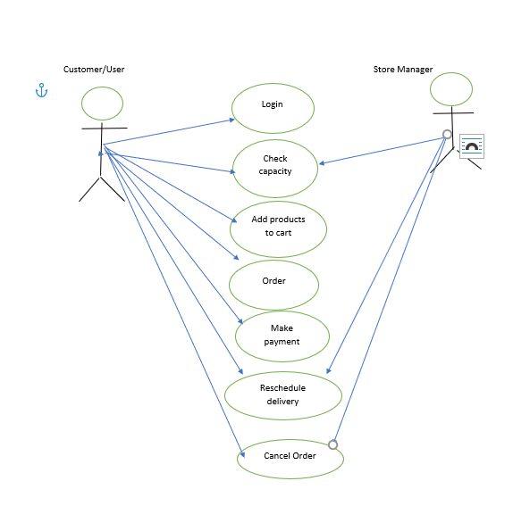

* **Sequence Diagrams**

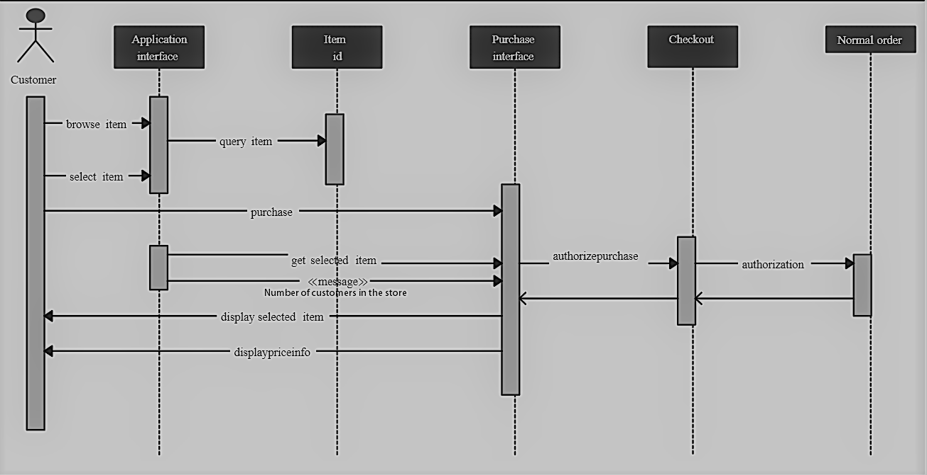

* **Collaboration Diagram**

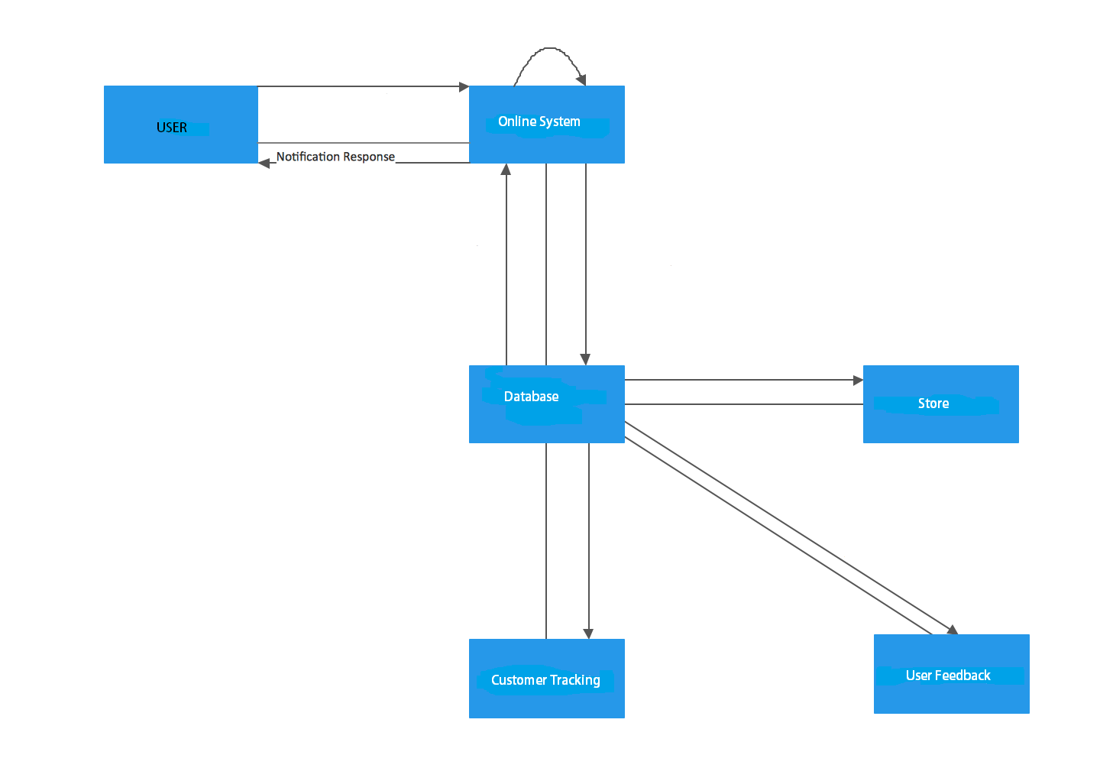

* **Relational Database Design.**

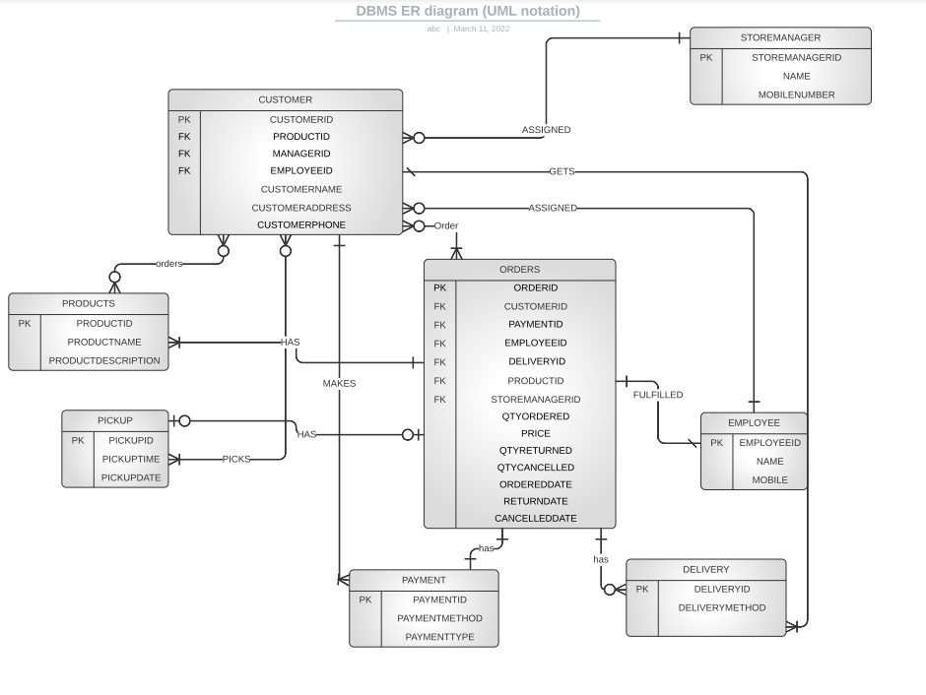

* **User-Interface Design & Design Validation—Customer Acceptance of the Low-Fidelity Prototypes**

Initial interface shown here. For full interface walkthrough and prototype code, please see Low Fidelity Prototype Walkthrough Final.docx available on GitHub (<https://github.com/BryanMiletta/CS790-Team-4>) and accompanying code on GitHub.

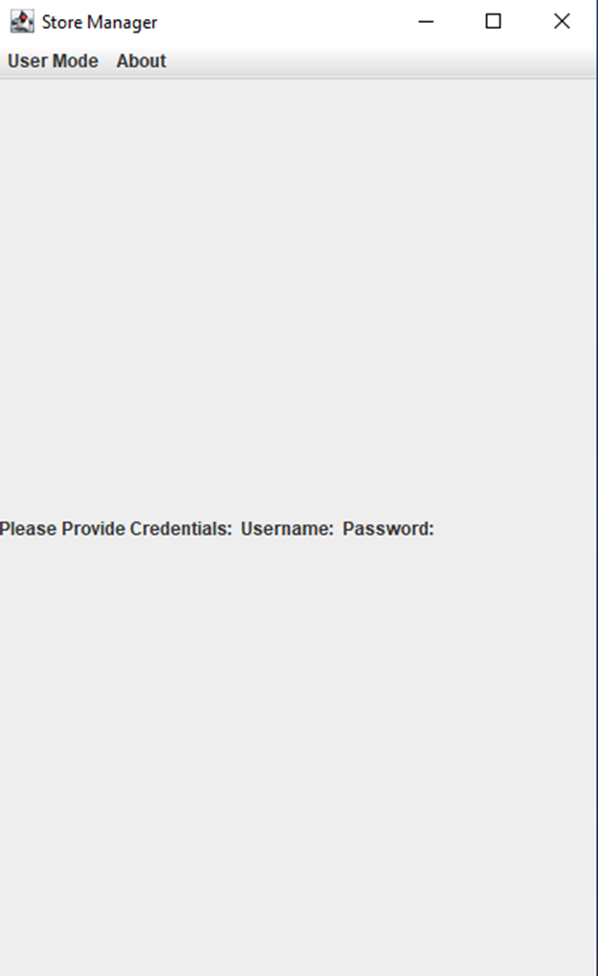

* **Review of progress since the previous milestone.** 
  + System maturation from very high level to more detailed class structures. Our refinement of use cases and our validation plan helped us focus the scope.
  + Exploration of Database architecture and applications to our system
  + Refined program scope / tasks to align with the newest learned information
  + System simplification due to our Milestone 2 investigation about what’s in scope and out of scope.
  + Optimized team collaboration. It took a few weeks to get in sync but now our communication methods and collaboration is functioning like a well oiled machine.
  + Updated program plan.
* **Revised schedule and plan for the remainder of the project.** 
  + (Complete and committed to github)